## **Validation**

Please follow the below examples to validate that you have successfully installed the Catch cartridge.

## **Business Manager**

All cartridge components are located in "Merchant Tools > Site Preferences > Custom Site Preference > Catch".

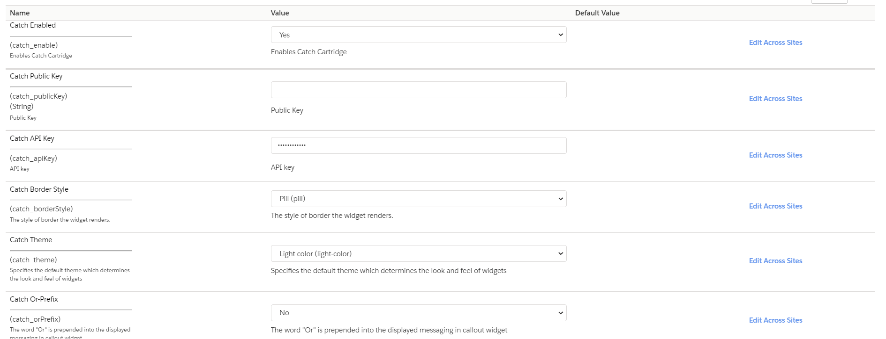

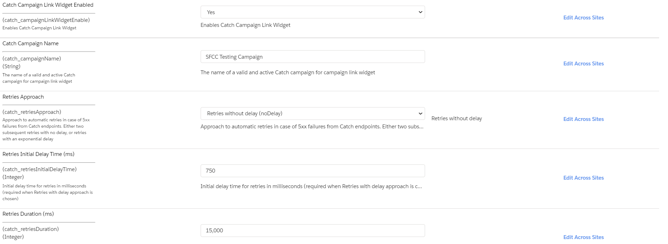

Catch service needs to be enabled. Specify your *Catch Public Key* and *Catch API Key*.

Go to "Merchant Tools > Ordering > Payment Methods" and make sure then the Catch payment method is enabled.

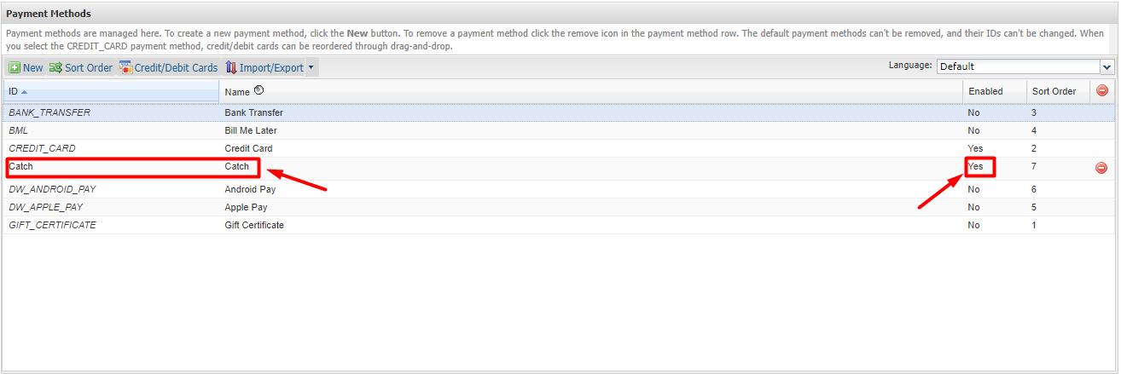

## **Storefront**

Select a product and go to the PDP. The PDP should have the Catch widget.

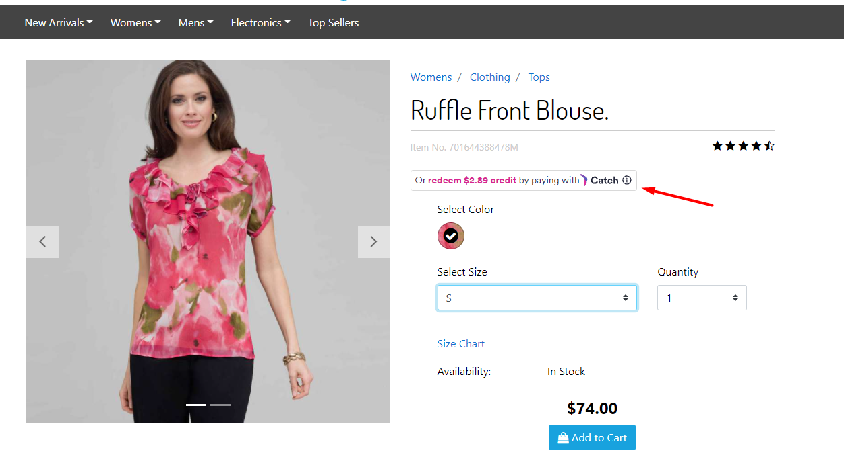

Add the product to the cart and go to the checkout payment page. On the payment page should have the Catch payment method and Catch widget.

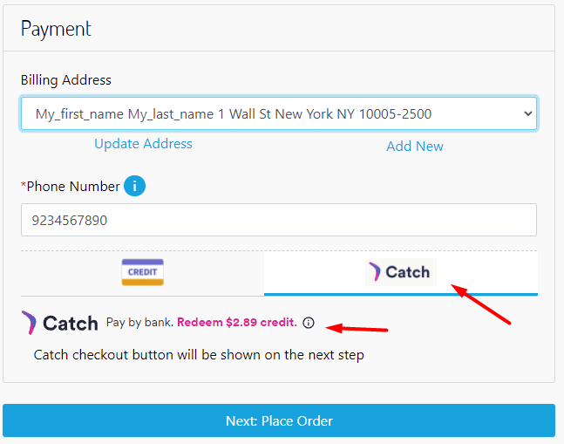

Select the Catch payment method and submit payment. On the confirmation page confirm your order. The Catch payment page should open.

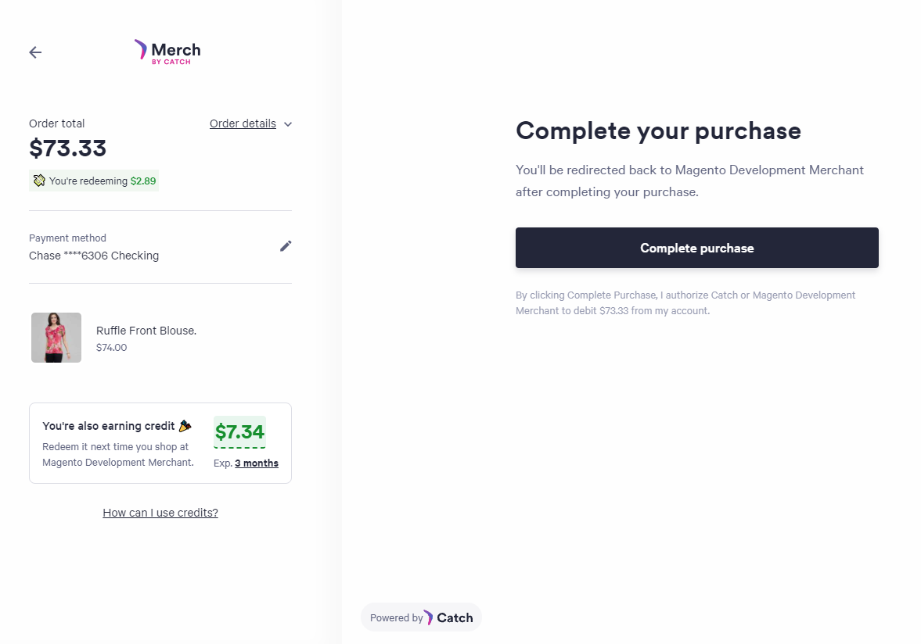

Refund

**Note**: order total won't be changed in BM, only visible in JSON on the controller page.

Place order using Catch payment method. In the browser’s address bar call the Refund controller by placing the URL address in the following format:

LINK_TO_STOREFRONT/Catch-Refund?order=SFCC_ORDER_NO&amount=REFUND_AMMOUNT&refundid=1234, where:

LINK_TO_STOREFRONT - link to the current storefront

SFCC_ORDER_NO - order number placed on SFCC side

REFUND_AMMOUNT - amount of funds to be returned

Result should be visible in JSON format on the page:

{

"refund": {

"id": string,

"purchase_id": string,

"refund_amount": {

"amount": integer(cents),

"Currency": string

}

}

}